Maestro Reservation Daily Main.

Run these 2 reports daily
- Maestro error log (once/day in low season; twice/day in high season – morning and afternoon)
- Reservation Log – Name List (at the afternoon)

Maestro Error Log
- Go to On-Request report and run Maestro Reservation Error Report
- Enter the following parameters for the error report
Begin Date: Date and time of the last report run
End Date: Current date + 23:59
Error Level: All error level
Error Type: System and User
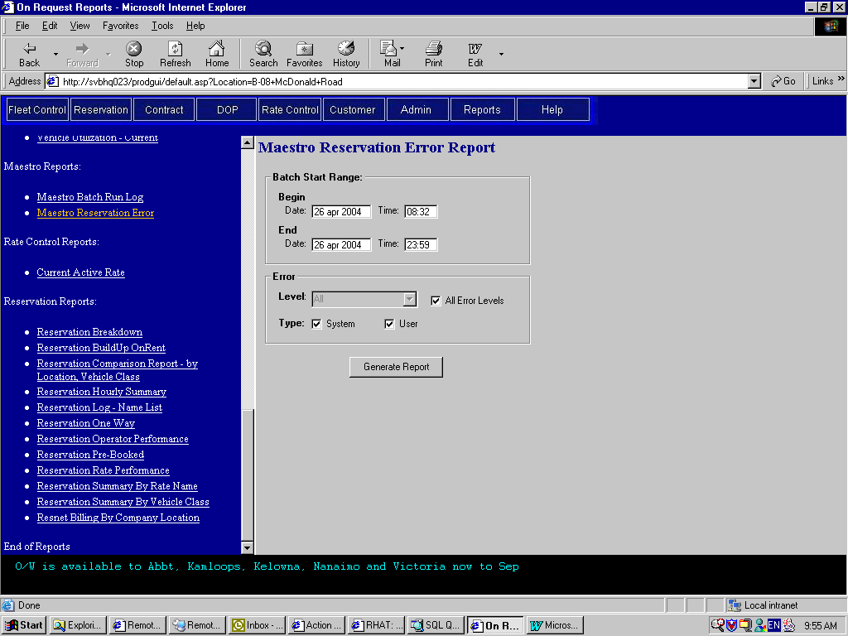

- After generated the report, print it.

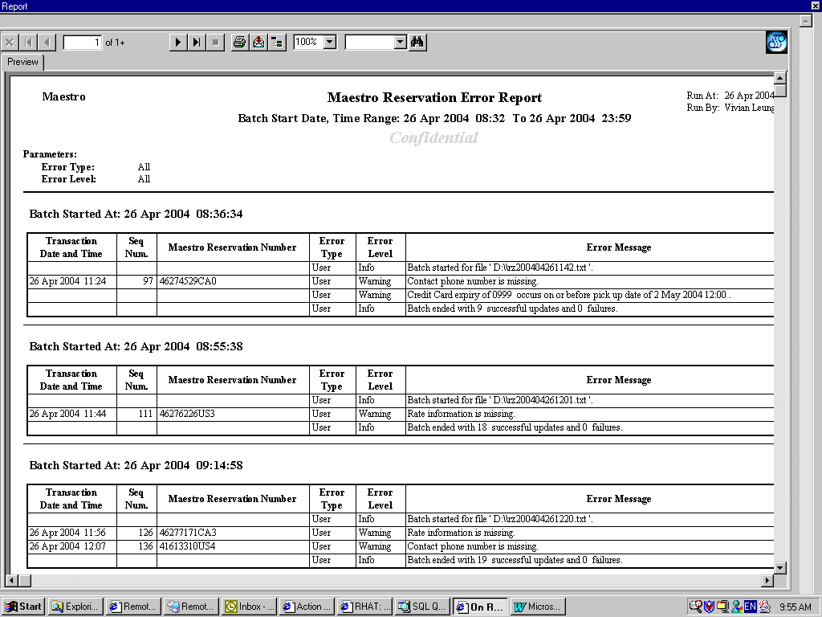
- Check the following in the report
- Transaction time is up-to-date and no missing date
- Batch is in sequence and no missing batch
- Error Level is Error. It means the new information is not updated in the system.
- Any Rate related error messages. It means there may be some problems with the rate delivered.
- Occasionally, pay attention to Warning messages.

- Problems:
- Transaction date/time is not up-to-date
S: Check Maestro loader, reservations may not be pulled for a while.
- Transaction date/time or batch is missing
S: Log on to Maestro terminal, go to b520 screen.
Type in: Command: PUL
Routing code: yvr91
Transaction Date: Date of the transaction
Sequence start:
Sequence end:
- Rate is missing
S: Log on to Maestro terminal, go to b502 screen
Type in: qr or dr at the left-handed top corner
r/res_num in the NAM field
Look for the rate amount and enter the corresponding GIS rate to reservation.
If no rate is quoted in Maestro, use the current GIS rack rate.
If tour rate is quoted in Maestro, look at the BCD# or the rate code to get the correct GIS tour rate.
- Error level is Error and reservation info is not updated
S: Look at the error message to find the problems and resolve accordingly.
For instance, no matching data structure; no matching vehicle class code; etc.
Contact IT department for assistance.

Reservation Log – Name List
- Go to On-Request report and run Reservation Log – Name List report
- Use the following parameters:
Source: Maestro
Vehicle Type: All
Vehicle Class: All
Company: a/BRAC of BC Ltd.
Pick up Location: All
Pick up Date start: the next date
Pick up Date end: the next date (If the current day is Friday, use next Monday’s date)
Include No Show: No need to check for future reservations.
Sort by: Pick up time

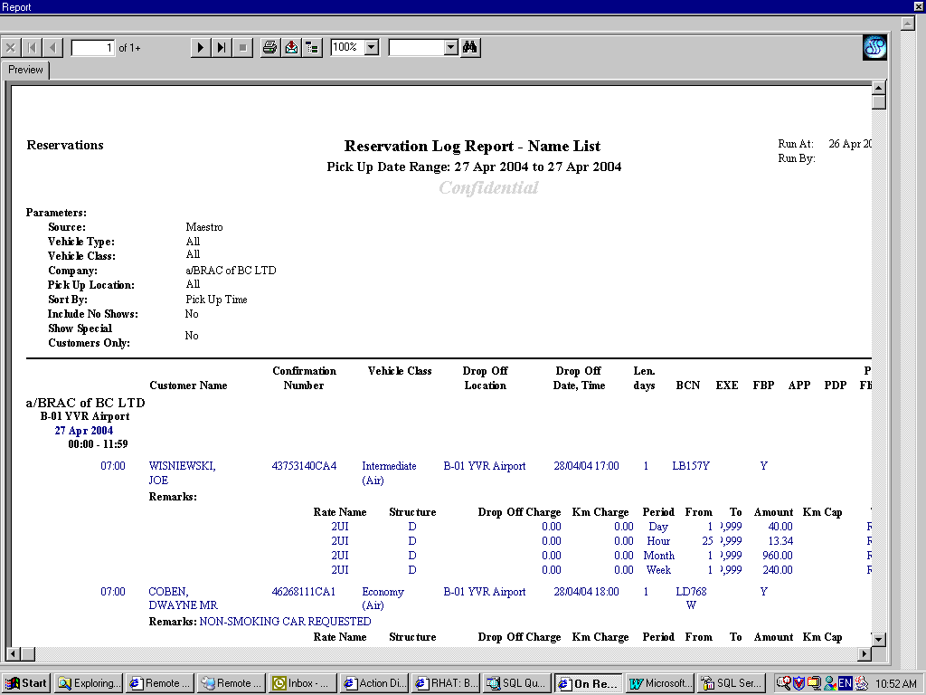
- Print report and check the followings:
- Reservations with no rates
- Rate amounts and vehicle class
- Rate code, may happen to have unexpected rate code delivered to us.
- Pick up location (specially the seasonal pick up locations)

- For missing rate, check the reservation in GIS first. If you did Maestro Error log daily, there should not be any missing rates. If there is missing rate, go to Maestro terminal to retrieve reservation and assign corresponding GIS rate

